Instructions for use

These plain language genomic test report templates are set up using Microsoft Forms fields. These allow for the report to be locked to avoid changes to the template, while still enabling personalisation.

When the report is unlocked, the report is fully modifiable, and form fields can be deleted.

When the report is protected (enabled in the ‘Developer’ tab in Microsoft Word), all sections excluding ‘What happens next’, ‘Your genetic team’, and ‘Community supports’ will be locked so that only fields in grey can be modified. The grey shading will not appear when the document is printed or saved as a PDF.

The plain language genomic test report templates are enclosed below in the following order:
- Page 2: de novo dominant
- Page 3: inherited autosomal dominant
- Page 4: autosomal recessive
- Page 5: X-linked recessive
- Page 6: X-linked de novo
- Page 7: mitochondrial
- Page 8: variant(s) of uncertain significance with high clinical relevance (i.e., strongly suspected to be causing the phenotype)​
- Page 9: uninformative result (i.e., no variants reported)

Patient name’s Genomic Test Results Family Report Issued: 27/5/22
Parents’ names | Parents' names  Study ID: A Testing Laboratory:  Sample IDs: Patient – 22W , Mum – 22W , Dad – 22W
Reason for test | Unexplained seizures in Patient
About the test | We performed a ‘trio whole genome sequencing’ (trio WGS) test. This test examines your and patient’s genetic information to try and find a cause for patient’s condition. You can find links to more information about this test at the bottom of this document.
Patient’s result | KCNQ2-related epileptic encephalopathy  Gene: KCNQ2  Variant: NM_ : c.369C>G, p.Arg123Cys
Inheritance and recurrence | 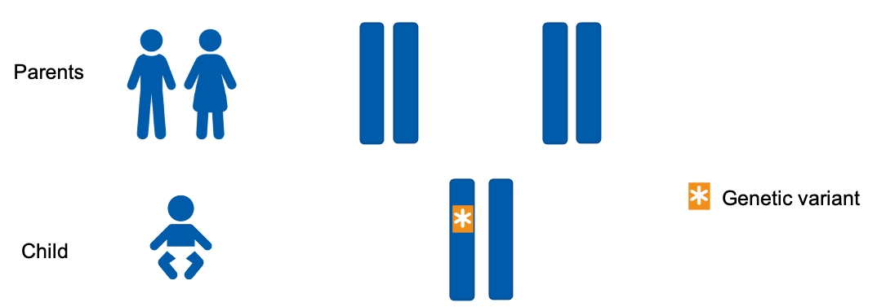  Inheritance pattern: Patient has not inherited the KCNQ2 gene variant, it has occurred in him/her for the first time (it is de novo).  Recurrence: Parents' names, you have a low chance of recurrence in future pregnancies for this condition. You have options for testing to avoid a recurrence and can discuss these in more detail with your genetics team.

What happens next | Clinical recommendations: You will be advised by the Neurology team whether any changes to patient’s seizure medication are necessary.  Data storage and re-analysis: Your and patient’s genomic data will be stored securely and can be re-analysed in the future if new clinical questions arise.
Your genetic team | We will work together with the other medical teams involved in patient’s care.  Clinical geneticist:  Genetic counsellor:  Genetics follow up:
Community supports | 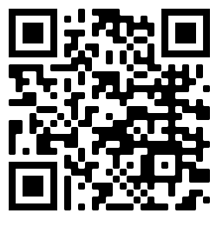  Further resources and community support networks:  - Genomics Info - genomicsinfo.org.au  - SWAN Australia - swanaus.org.au  - Genetic Alliance Australia - geneticalliance.org.au  Scan the QR code for more information on genomics  - MedlinePlus Genetics - medlineplus.gov/genetics

Patient Name’s Genomic Test Results Family Report Issued: 27/5/22
Parents’ names | Parent's names  Study ID: A Testing Laboratory:  Sample IDs: Patient – 22W , Mum – 22W , Dad – 22W
Reason for test | Unexplained cardiac arrest
About the test | We performed a ‘trio whole genome sequencing’ (trio WGS) test. This test examines your and patient’s genetic information to try and find a cause for patient’s condition. You can find links to more information about this test at the bottom of this document.
Patient’s result | Long QT syndrome  Gene: SCN5A  Variant: NM_ : c.369C>G, p.Arg123Cys
Inheritance and recurrence | Inheritance pattern: The SCN5A gene variant in Patient has been inherited from mum/dad.  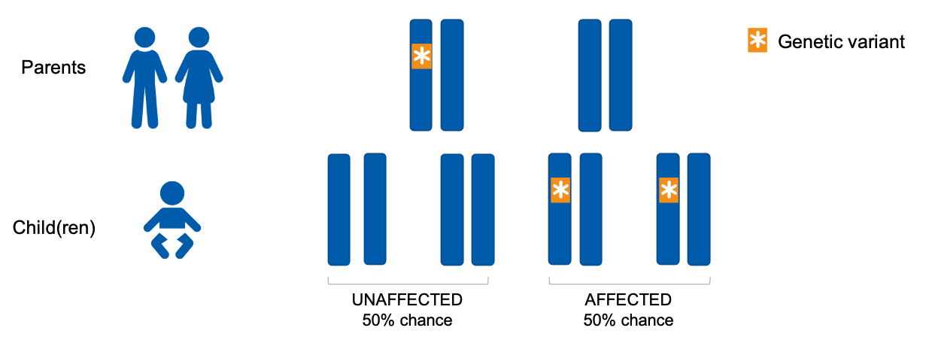  Recurrence: Parents' names, you have a 1 in 2, or 50%, chance of recurrence in each future pregnancy for the two of you. You have options for testing to avoid a recurrence and can discuss these in more detail with your genetics team. mum/dad, other members of your family are also at risk of Long QT syndrome.

What happens next | Clinical recommendations: The Cardiology team will discuss management options with you. mum/dad, we will refer you to a cardiology specialist and we will discuss recommendations for testing other family members further.  Data storage and re-analysis: Your and patient’s genomic data will be stored securely and can be re-analysed in the future if new clinical questions arise.
Your genetic team | We will work together with the other medical teams involved in patient’s care.  Clinical geneticist:  Genetic counsellor:  Genetics follow up:
Community supports | Further resources and community support networks:  - Genomics Info - genomicsinfo.org.au  - SWAN Australia - swanaus.org.au  - Genetic Alliance Australia - geneticalliance.org.au  Scan the QR code for more information on genomics  - MedlinePlus Genetics - medlineplus.gov/genetics

Patient Name’s Genomic Test Results Family Report Issued: 27/5/22
Parents’ names | Parents' names  Study ID: A Testing Laboratory:  Sample IDs: Patient – 22W , Mum – 22W , Dad – 22W
Reason for test | Congenital diarrhoea
About the test | We performed a ‘trio whole genome sequencing’ (trio WGS) test. This test examines your and patient’s genetic information to try and find a cause for patient’s condition. You can find links to more information about this test at the bottom of this document.
Patient’s result | Microvillus inclusion disease  Gene: MYO5B  Variant: NM_ : c.369C>G, p.Arg123Cys and c.1053A>C, p.Glu351*
Inheritance and recurrence | Inheritance pattern: The two MYO5B gene variants in Patient have been inherited. Patient has inherited the c.369C>G, p.Arg123Cys from mum and the c.1053A>C, p.Glu351* from dad. Parents' names, you are both healthy ‘carriers’ for microvillus inclusion disease.  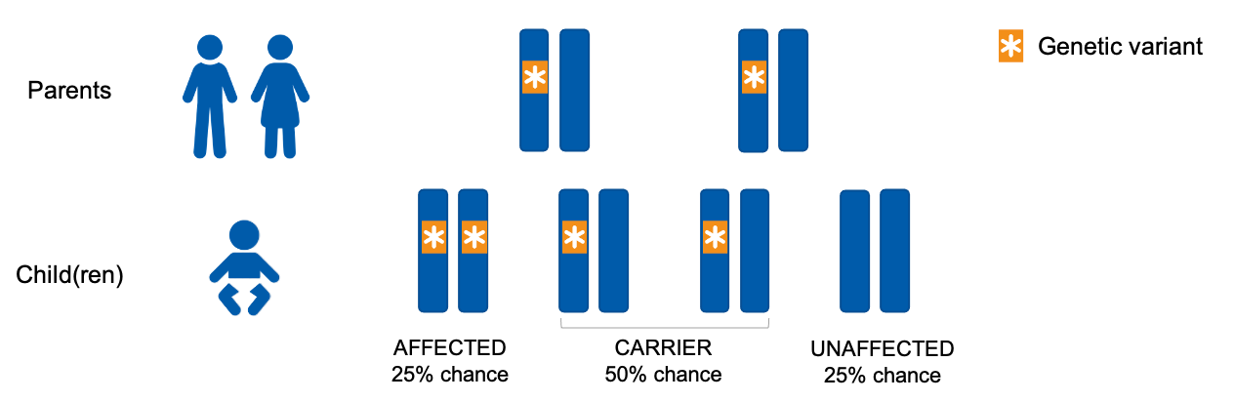  Recurrence: Parents' names, you have a 1 in 4, or 25%, chance of recurrence in each future pregnancy for the two of you. You have options for testing to avoid a recurrence and can discuss these in more detail with your genetics team.

What happens next | Clinical recommendations: You will be advised by the Gastroenterology team whether any changes to patient’s medication are necessary.  Data storage and re-analysis: Your and patient’s genomic data will be stored securely and can be re-analysed in the future if new clinical questions arise.
Your genetic team | We will work together with the other medical teams involved in patient’s care.  Clinical geneticist:  Genetic counsellor:  Genetics follow up:
Community supports | Further resources and community support networks:  - Genomics Info - genomicsinfo.org.au  - SWAN Australia - swanaus.org.au  - Genetic Alliance Australia - geneticalliance.org.au  Scan the QR code for more information on genomics  - MedlinePlus Genetics - medlineplus.gov/genetics

Patient Name’s Genomic Test Results Family Report Issued: 27/5/22
Parents’ names | Parents' names  Study ID: A Testing Laboratory:  Sample IDs: Patient – 22W , Mum – 22W , Dad – 22W
Reason for test | Seizures and developmental delay
About the test | We performed a ‘trio whole genome sequencing’ (trio WGS) test. This test examines your and patient’s genetic information to try and find a cause for patient’s condition. You can find links to more information about this test at the bottom of this document.
Patient’s result | Menke's disease  Gene: ATP7A  Variant: NM_ : c.1053A>C, p.Glu351*
Inheritance and recurrence | Inheritance pattern: Mum, patient has inherited the ATP7A gene variant from you. Mum, you are a healthy ‘carrier’ for Menke’s disease, and other members of your family may also be carriers.  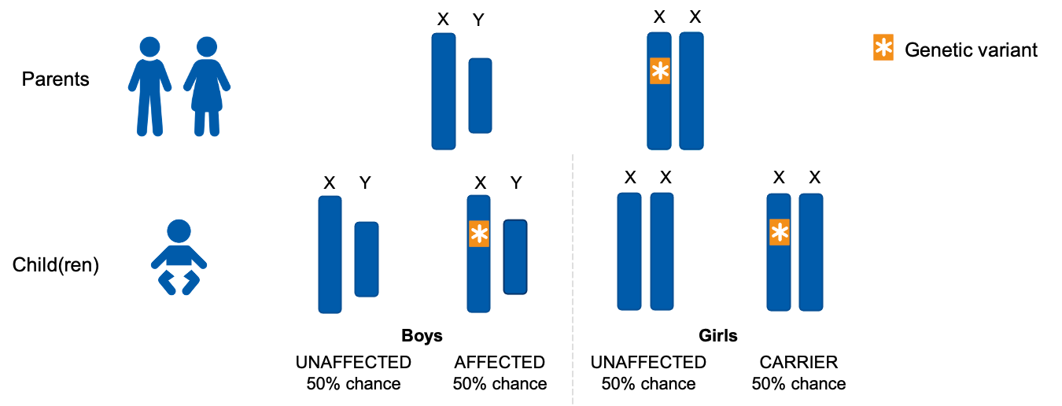  Recurrence: Parents' names, you have a 1 in 4, or 25%, chance of recurrence in each future pregnancy for the two of you. You have options for testing to avoid a recurrence and can discuss these in more detail with your genetics team.

What happens next | Clinical recommendations: The Metabolic team will discuss management options with you.  Data storage and re-analysis: Your and patient’s genomic data will be stored securely and can be re-analysed in the future if new clinical questions arise.
Your genetic team | We will work together with the other medical teams involved in patient’s care.  Clinical geneticist:  Genetic counsellor:  Genetics follow up:
Community supports | Further resources and community support networks:  - Genomics Info - genomicsinfo.org.au  - SWAN Australia - swanaus.org.au  - Genetic Alliance Australia - geneticalliance.org.au  Scan the QR code for more information on genomics  - MedlinePlus Genetics - medlineplus.gov/genetics

Patient Name’s Genomic Test Results Family Report Issued: 27/5/22
Parents’ names | Parents' names  Study ID: A Testing Laboratory:  Sample IDs: Patient – 22W , Mum – 22W , Dad – 22W
Reason for test | Seizures and developmental delay
About the test | We performed a ‘trio whole genome sequencing’ (trio WGS) test. This test examines your and patient’s genetic information to try and find a cause for patient’s condition. You can find links to more information about this test at the bottom of this document.
Patient’s result | Menke's disease  Gene: ATP7A  Variant: NM_ : c.1053A>C, p.Glu351*
Inheritance and recurrence | 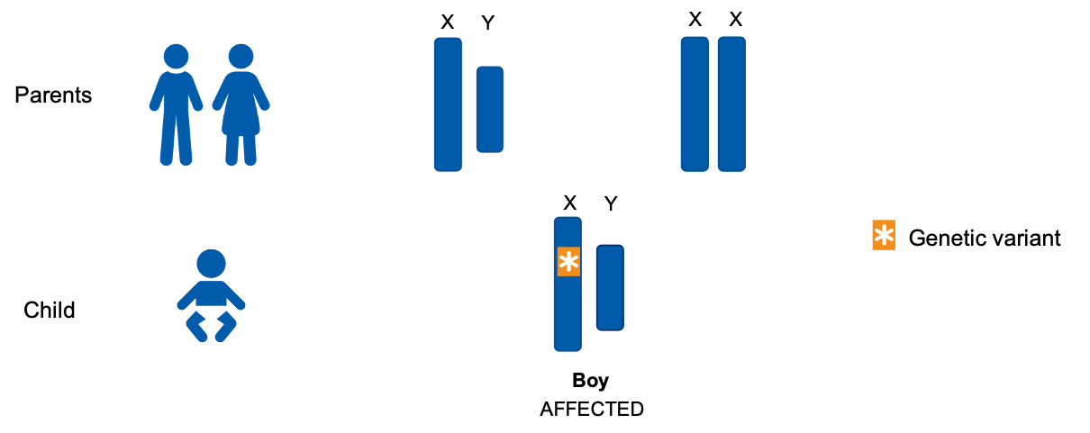  Inheritance pattern: Patient has not inherited the ATP7A gene variant, it has occurred in him/her for the first time (it is de novo).  Recurrence: Parents' names, you have a low chance of recurrence in future pregnancies for this condition. You have options for testing to avoid a recurrence and can discuss these in more detail with your genetics team.

What happens next | Clinical recommendations: The Metabolic team will discuss management options with you.  Data storage and re-analysis: Your and patient’s genomic data will be stored securely and can be re-analysed in the future if new clinical questions arise.
Your genetic team | We will work together with the other medical teams involved in patient’s care.  Clinical geneticist:  Genetic counsellor:  Genetics follow up:
Community supports | Further resources and community support networks:  - Genomics Info - genomicsinfo.org.au  - SWAN Australia - swanaus.org.au  - Genetic Alliance Australia - geneticalliance.org.au  Scan the QR code for more information on genomics  - MedlinePlus Genetics - medlineplus.gov/genetics

Patient Name’s Genomic Test Results Family Report Issued: 27/5/22
Parents’ names | Parents' names  Study ID: A Testing Laboratory:  Sample IDs: Patient – 22W , Mum – 22W , Dad – 22W
Reason for test | Suspected optic neuropathy
About the test | We performed a ‘trio whole genome sequencing’ (trio WGS) test. This test examines your and patient’s genetic information to try and find a cause for patient’s condition. You can find links to more information about this test at the bottom of this document.
Patient’s result | Leber hereditary optic neuropathy  Gene: MT-ND4  Variant: NC_012920.1: m.11778G>A, p.(Arg340His)
Inheritance and recurrence | 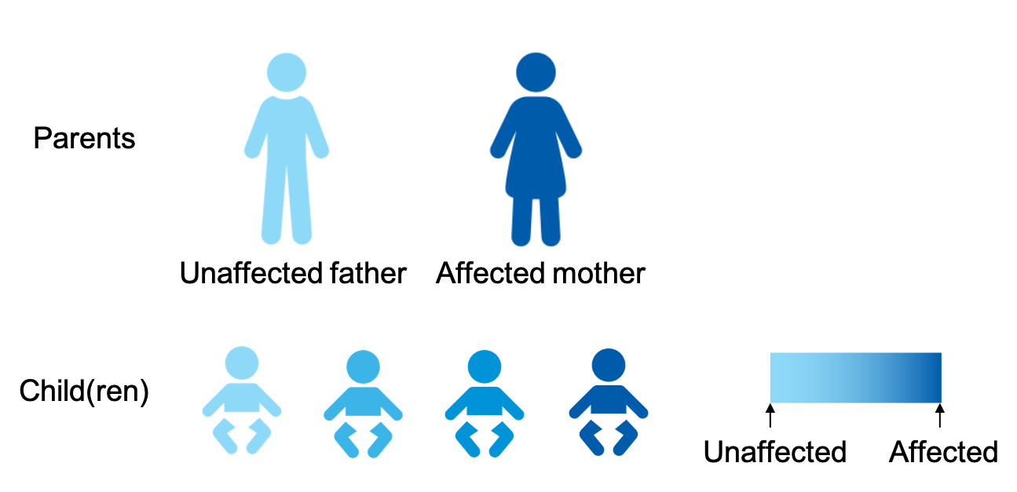  Inheritance pattern:  Recurrence:

What happens next | Clinical recommendations: The Metabolic team will discuss management options with you.  Data storage and re-analysis: Your and patient’s genomic data will be stored securely and can be re-analysed in the future if new clinical questions arise.
Your genetic team | We will work together with the other medical teams involved in patient’s care.  Clinical geneticist:  Genetic counsellor:  Genetics follow up:
Community supports | Further resources and community support networks:  - Genomics Info - genomicsinfo.org.au  - SWAN Australia - swanaus.org.au  - Genetic Alliance Australia - geneticalliance.org.au  Scan the QR code for more information on genomics  - MedlinePlus Genetics - medlineplus.gov/genetics

Patient Name’s Genomic Test Results Family Report Issued: 27/5/22
Parents’ names | Parents' names  Study ID: A Testing Laboratory:  Sample IDs: Patient – 22W , Mum – 22W , Dad – 22W
Reason for test | Hydrops
About the test | We performed a ‘trio whole genome sequencing’ (trio WGS) test. This test examines your and Patient’s genetic information to try and find a cause for Patient’s condition. You can find links to more information about this test at the bottom of this document.
Patient’s result | No genetic diagnosis was made  However, two gene variants were identified that may be indicative of Nemaline myopathy 2. At the present time, we do not have enough evidence to be certain they are responsible for Patient’s condition.  Gene: NEB  Variant: NM_1111: c.274G>T, p.Asp92Tyr (variant of uncertain significance) and c.274G>T, p.Asp92Tyr (variant of uncertain significance)
Inheritance | The two gene variants have been inherited from both of you. Charlie has inherited the c.274G>T, p.Asp92Tyr from Mum and the c.274G>T, p.Asp92Tyr from Dad.

What happens next | Clinical recommendations: if applicable, can be deleted if not  Data storage and re-analysis: Your and Patient’s genomic data will be stored securely and can be re-analysed in the future if new clinical questions arise.
Your genetic team | We will work together with the other medical teams involved in Patient’s care.  Clinical geneticist:  Genetic counsellor:  Genetics follow up:
Community supports | Further resources and community support networks:  - Genomics Info - genomicsinfo.org.au  - SWAN Australia - swanaus.org.au  - Genetic Alliance Australia - geneticalliance.org.au  Scan the QR code for more information on genomics  - MedlinePlus Genetics - medlineplus.gov/genetics

Patient Name’s Genomic Test Results Family Report Issued: 27/5/22
Parents’ names | Parents' names  Study ID: A Testing Laboratory:  Sample IDs: Patient – 22W , Mum – 22W , Dad – 22W
Reason for test | Unexplained seizures in Charlie
About the test | We performed a ‘trio whole genome sequencing’ (trio WGS) test. This test examines your and patient’s genetic information to try and find a cause for patient’s condition. You can find links to more information about this test at the bottom of this document.
Patient’s result | No genetic diagnosis was made
Possible reasons for result | - The cause of Patient’s seizures may not be genetic  - The cause of Patient's seizures may be genetic, but  - the particular gene change causing his/her seizures may be difficult to detect and interpret with current technology and knowledge  - may be due to a change in a gene that is yet to be linked to health problems

What happens next | Clinical recommendations: if applicable, can be deleted if not  Data storage and re-analysis: Your and patient’s genomic data will be stored securely and can be re-analysed in the future if new clinical questions arise.
Your genetic team | We will work together with the other medical teams involved in patient’s care.  Clinical geneticist:  Genetic counsellor:  Genetics follow up:
Community supports | Further resources and community support networks:  - Genomics Info - genomicsinfo.org.au  - SWAN Australia - swanaus.org.au  - Genetic Alliance Australia - geneticalliance.org.au  Scan the QR code for more information on genomics  - MedlinePlus Genetics - medlineplus.gov/genetics

