Genomic Testing Fact Sheet

This fact sheet aims to help you discuss the consent form for genomic testing with your health professional. The consent form needs to be signed before genomic testing is started. It is your choice whether to have this test.
Questions to ask your doctor/genetic counsellor
- What is the chance that the genomic test will identify the cause of my/my child's condition?
- How long will it take to get a result?
- Who will give me the result and how?
- Where will my genomic test be done?
- What is the cost to me (if any) of my genomic test?
- What can this mean for other members of my family if I have this test?
- What is the chance of this test finding something that is unrelated to my/my child’s current health condition?

What is genomic testing?
Our bodies are made up of billions of cells. In most of our cells we have a complete copy of our genetic information (genome). We all have about 20,000 genes in our genomes. Our genes are made of DNA and contain the instructions for growth and development of the body. Until recently, doctors and scientists were only able to test one gene at a time. Genomic technology allows us to test many of our genes at once (genomic testing).
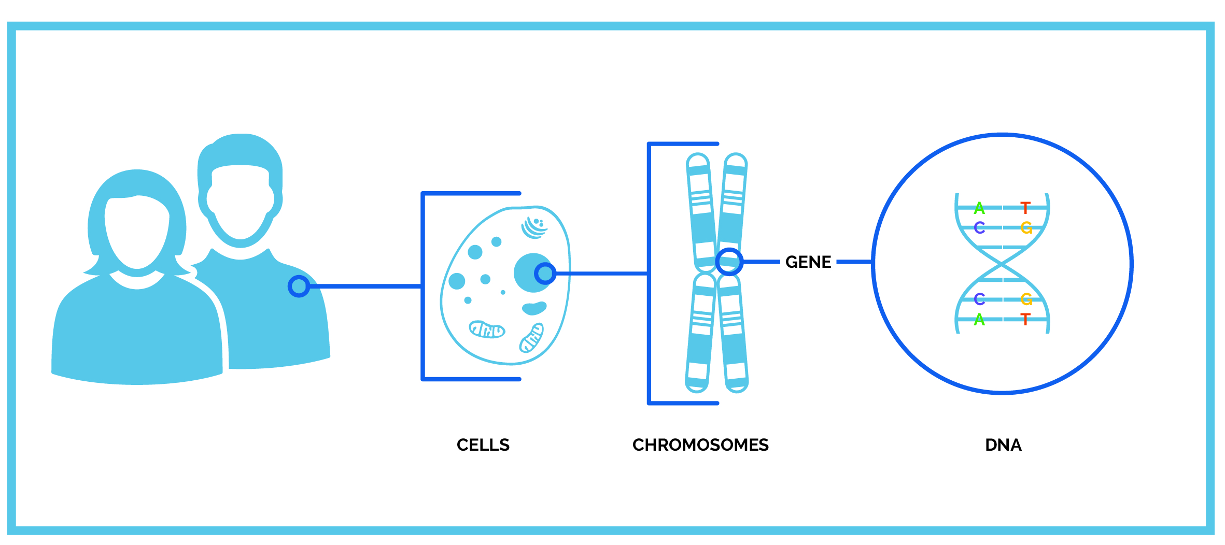
DNA for testing comes from blood, tissue, saliva, or mouth swab.
DNA can be taken from your body cells to identify changes that contribute to or cause disease.
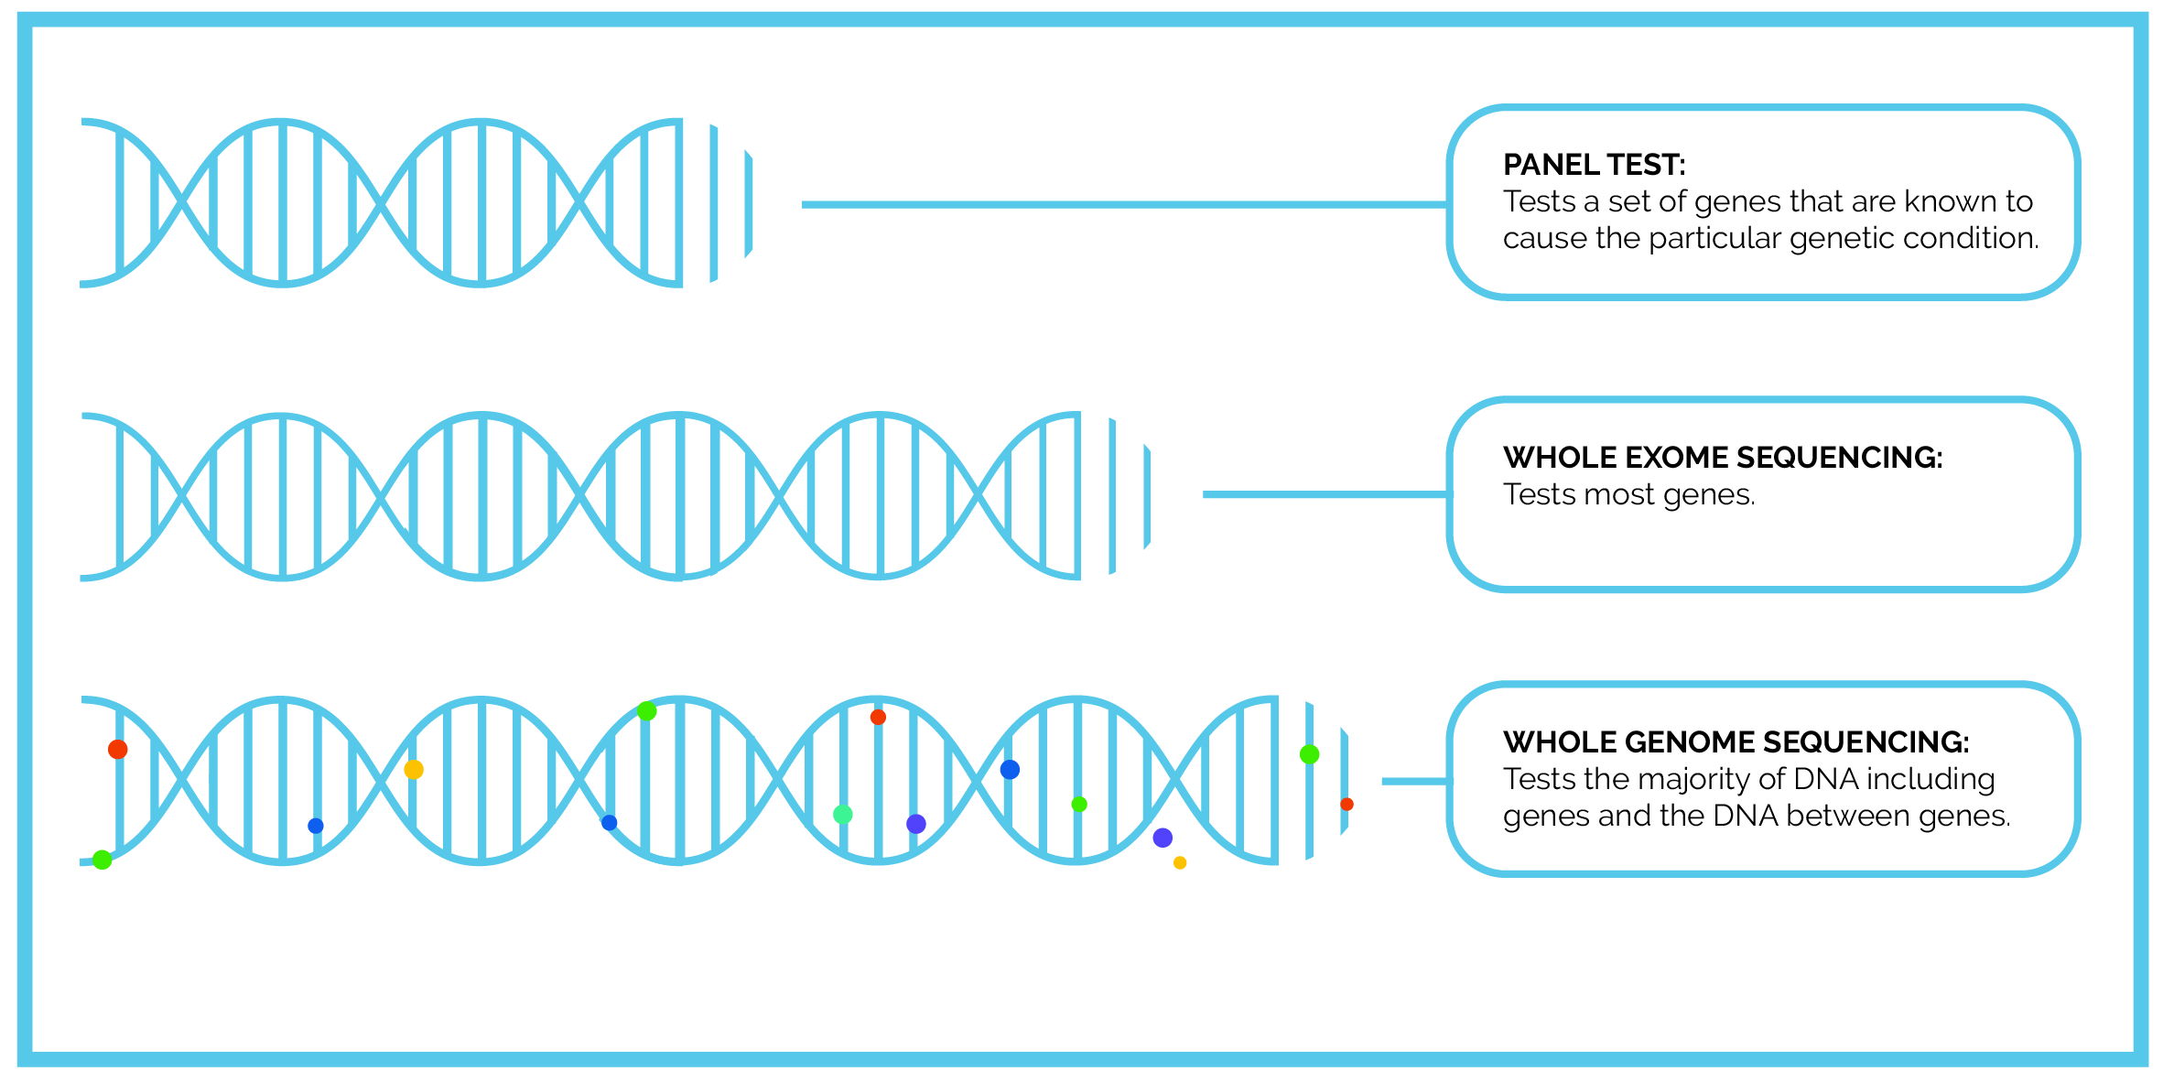

What are genetic variants?
Each person’s genome contains many genetic differences (variants). Most of these are harmless and do not change how the gene works in the body. Genomic testing is done to find variants that do change how a gene works and therefore cause genetic conditions.
Example:
Think of a gene as like a sentence in an instruction manual.

Consider the sentence:

MUM CUT THE HOT DOG The gene works as it should.

MOM CUT THE HOT DOG Some spelling changes look different but don’t change the meaning of the sentence. Therefore, the gene still works.
MXM CUT THE HOT DOG Other spelling changes look different and do change the meaning. Therefore, the gene doesn’t work.
MEM CUT THE HOT DOG Other spelling changes look different but we do not know if the meaning changes. Therefore, we are uncertain what the effect on the gene might be.
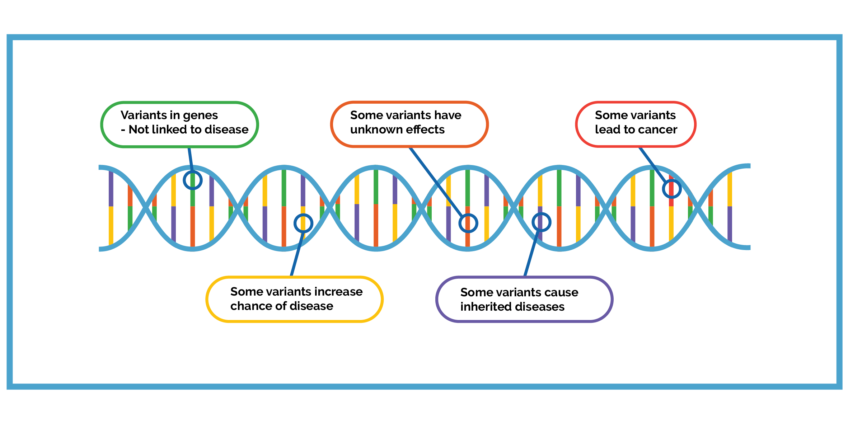

Different types of DNA variants have different effects on the genetic code and body functions.

Potential outcomes of genomic testing
The test may:
- find a cause of the condition.
- not find a cause that could explain the condition.
- find a result of ‘variant of unknown significance’ (VUS), which means that it cannot be understood today. Sometimes testing in other family members for the VUS may help to understand if it could be the cause of a condition. The understanding of VUS may change over time. Future testing may help clarify this.
A cause for the condition may not be found for a number of reasons, including:
- the variant causing the condition cannot be found by the test;
- the gene causing the condition was not tested;
- the gene causing the condition is not yet known.

Why genomic testing?
Some reasons people have genomic testing are:
- to find a genetic diagnosis for their or their child’s condition.
- to help families understand the condition, access support they need, and plan for the future.
- to help health professionals manage a condition.
- to provide families with information about the chance of having another child with the same condition.
Sometimes, the genomic test result in one person may also be important for the care of their relatives.
If a diagnosis does not happen today, the genomic test result could be looked at in the future as our understanding improves.

It is important to remember that genomic testing is not a general health test and will not identify all gene changes that could contribute to health problems that may develop in the future.

Other things to think about

Incidental findings
As this test looks at many genes at once, there is a small chance a variant may be found in a gene that is not related to your health condition. Such ‘incidental findings’ could be important to know about for your health. If your doctor thinks that an incidental finding may be important for you or other family members, they will raise it with you.

Insurance
In Australia, genomic testing will not alter your ability to get health insurance or your health insurance premiums. Genomic testing in you or your child could affect how easy it is for you or other family members to get income protection, travel or life insurance; or the price of your premium. From July 2019 to June 2024 the life insurance industry has put in place a moratorium to allow people to access a level of life insurance without being asked about the result of a previously taken genetic test. An existing diagnosis may already affect your ability to obtain these kinds of insurance. Industry regulation prevents insurers from asking relatives for your genetic test results, and you cannot be requested to have a test by an insurer. Your healthcare provider will not provide your results to an insurance provider without your permission.

Further details can be found at: https://www.genetics.edu.au/publications-and-resources/facts-sheets/fact-sheet-20-life-insurance-products-and-genetic-testing-in-australia and by searching for ‘Moratorium’ at https://www.fsc.org.au/resources

Withdrawal from testing
You can change your mind about having genomic testing or being told the results. You can cancel the test at any time before the laboratory finishes the test. You can also choose not to be told the result after the test is finished, but the test result will be placed in your medical record.

Sharing results to help family members
Genetic services will not usually contact your family members. But, your relatives may be referred for genetic testing, when they find out there is a genetic condition in the family. Your test results may be released to another genetics service to help with the care of other family members, because genetic changes run in families. Genetic services need to share information, so that the correct testing can be offered to others. All efforts will be made to ensure that your identity is not revealed to those family members.

Data and Sample Sharing
Your results and genomic data will be stored securely in databases that meet Australian/international security standards and laboratory guidelines.

The health professionals involved in your care may order further testing of your sample or share your genomic data with each other to help work out what your test results mean. However, your results, genomic data and identified sample, or the fact that you have had genomic testing, will not be used or disclosed outside of your care without your consent, unless required or allowed by law.

Sharing of your genomic data and health information can advance scientific knowledge. This includes sharing gene variant information with large databases to help improve our understanding e.g. by comparing your results to those of other people.

When your data is shared there are safeguards in place to help protect your privacy, such as:
- Personal identifiers (information) will be removed (such as your name and address)
- Security measures that help prevent unauthorised access or misuse.

However, there is always a very small chance that you might be re-identified. Given that the potential to identify you is significantly reduced, you are unlikely to directly benefit from this sharing.
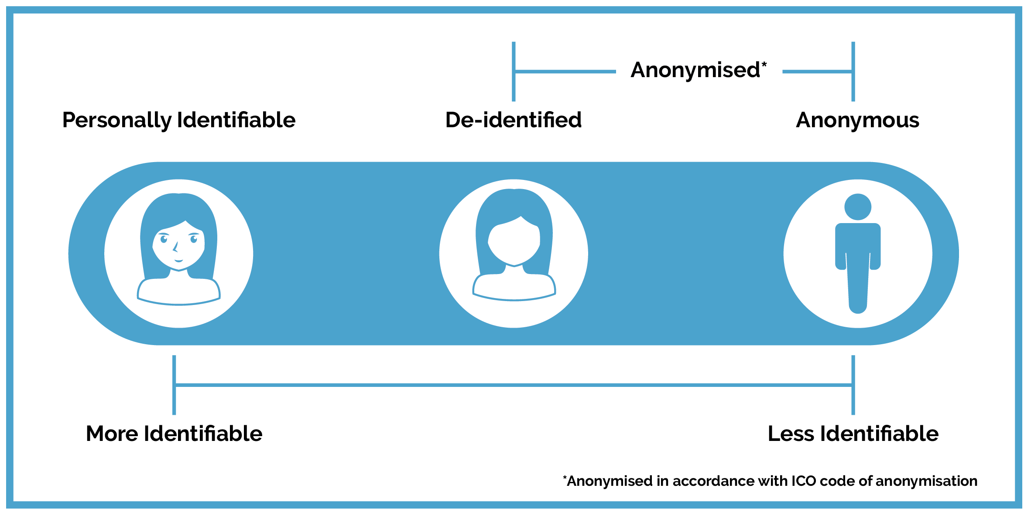
So why share my data?
You can also provide consent to sharing data for research into the same or a related condition in a way that may be linked back to you. The personal identifiers can be removed from your information or sample, and replaced by a code. If there are findings from this research that have implications for your clinical care, it may be possible to re-identify you, so that your results can be returned. However, participating in research does not guarantee direct benefits to you.

All researchers are bound by the law and ethical guidelines. This research will only happen for projects approved by a human research ethics committee. You can choose not to consent for research.

Questions?
This information sheet provides general information about genomic testing. It supports the information you should receive from a medical specialist or genetic counsellor. If you have any questions about the test or any of the information in this sheet, please contact your doctor or genetic counsellor.

